26. Develop a system using UML for Jewellery Shop Management System.

Sequence diagram:

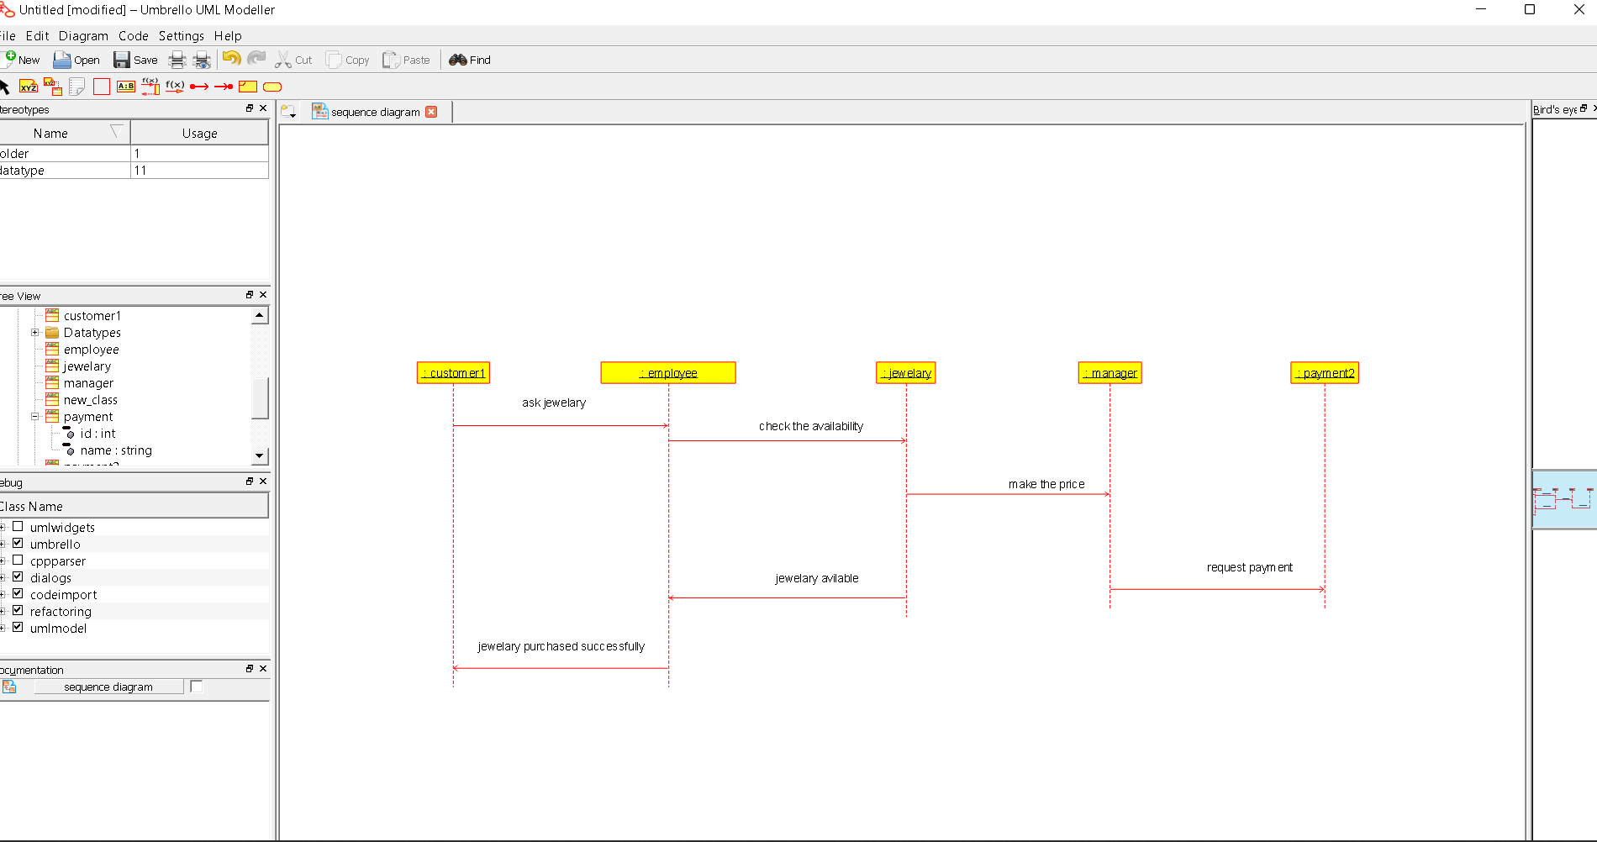

Actvity digram:

